Activity 1: Characters Chart
Complete the following based on your reading:
- Fill out the chart (a) and answer the question (b).

  - Identify the following features of Lucy’s skeleton as either primitive (chimpanzee-like) or derived (human-like).
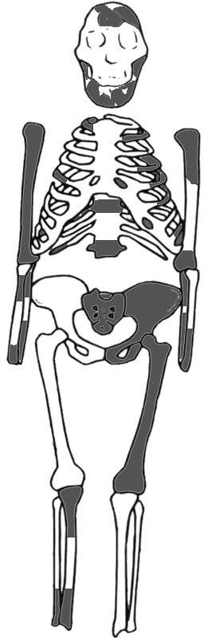
Prognathic face | Primitive
Brain size | Primitive
Valgus knee | Derived
Wide, short pelvis and sacrum | Derived

  - Using your answers from the chart above, how would you describe the overall anatomy of Lucy? On what do you base your conclusions?

The mosaic state of her anatomy suggested, for the first time, that early hominins engaged in both bipedalism and some arboreal locomotion, while still retaining a relatively small brain size. Even now, Lucy is often referred to during bipedalism debates, including the type of bipedalism A. afarensis and other early hominins might have utilized. The growth of high resolution X-ray scanning techniques may make it possible to look inside Lucy’s fossilized skeleton, and analyze the structure of her bones (i.e trabecular bone).

Activity 2: Primate Relationships
- Using the cladogram below, place the following labels on the blue lines to correctly depict the evolutionary relationships among these primates:

Humans Monkeys Australopithecus Apes

Now read the following clues. Identify when each of the derived traits listed in the box below evolved by writing it next to its corresponding arrow. When you are finished, answer the following questions.
Clue 1: All living apes lack tails.
Clue 2: The large human brain size is unique

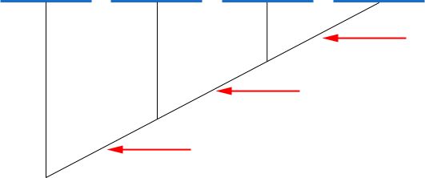
Monkeys Apes Australopithecus Humans
Bipedalism
Bigger brains
Tail loss
Derived Traits: Bipedalism Bigger Brains Tail Loss

  - What primates are characterized by bipedalism?

Bipedal walking is unique to hominins (A.afarensis and human).

  - Did bipedal locomotion or bigger brain size evolve first?

Hominins started walking bipedally long before the brain expanded.

Activity 3: Relative Brain Size
- Plot the relative brain sizes in order to observe any trends in brain size as they relate to a body mass scale (from small-bodied to large-bodied). You will plot the logarithm of body mass (a proxy for body size) and cranial capacity (a proxy for brain size) on the chart found on the following page. Take a look at the numbers in the parentheses in the table below. Notice how wide-ranging the numbers are. The raw body mass (measured in kilograms) of chimpanzees is 35 kg, while the body mass of gorillas is 105 kg. That means a gorilla is 3 times the weight of a chimpanzee. We would need a really big chart to fit all of those raw numbers on one graph! By logging these numbers, we reduce these values to a smaller scope. Basically, we make it easier to plot these values on the chart.

Taxon | X  Logged Body Mass (raw value in kilograms) | Y  Logged Cranial capacity (raw value in cubic centimeters)
Chimpanzee | 3.56 (35 kg) | 5.86 (350 cm³)
Gorilla | 4.65 (105 kg) | 6.27 (530 cm³)
Humans | 4.0 (57 kg) | 7.28 (1450 cm³)
Australopithecus | 3.61 (37 kg) | 6.06 (430 cm³)

Chimpanzee | Gorilla | Australopithecus | Human
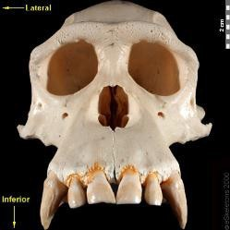 | 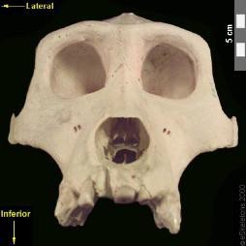 | 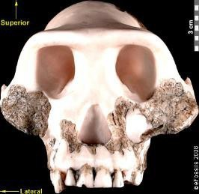 | 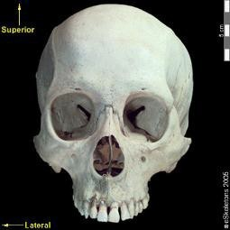

Have you ever plotted numbers on a graph before? It’s easy! The table above tells us that the X value is going to be “body mass”, and the Y value is going to be “cranial capacity.” The X value is always plotted on the horizontal axis and the Y value is always plotted on the vertical axis.
Let’s go over how we plotted our chimpanzee data point. First, find the X value for the chimpanzee body mass. It’s 3.56. Find 3.56 along the X axis with your finger. Second, find the Y values for chimpanzee cranial capacity. It’s 5.86. With your finger still on the
3.56 point along the horizontal axis, move your finger up the vertical axis until you reach 5.86. Plot your data point at the intersection of these two numbers.

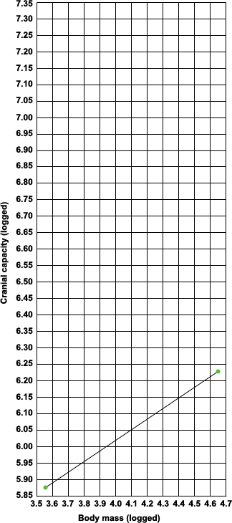

Because we’re interested in the brain sizes of humans and australopiths compared to those of living apes, we’ve gone ahead and plotted chimpanzees and gorillas for you. Then we drew a line connecting the chimpanzee and gorilla data points. This line is called a regression line, and illustrates any trends in the data. In this case, the regression line that we drew help us determine us what brain size we should expect in
X Humans
A. afarensis for any given body size, based on what we observe in living apes.
Let’s plot human and Australopithecus brain sizes. Then, turn to the page to continue.
X A.afarensis

- Take another look at the location of the human and A. afarensis data points. Are they above or below the trend line? If the data point falls below the trend line, then the observed brain size is relatively SMALL in comparison to living apes. If our data point falls above the trend line, then the observed brain size is relatively LARGE in comparison to living apes. Use this information, and the chart, to answer the following questions.

  - Is the relative cranial capacity of A. afarensis larger or smaller than that of the living African apes? How did you come to this conclusion?

Relative cranial capacity of A. afarensis is larger than that of living african apes, this is because the data falls above the trend line.

  - How do humans compare to both the living African apes and A. afarensis?

Humans have a relatively higher cranial capacity compared to both the living African apes and A. afarensis.

Activity 4: Bipedal Adaptations
- Recall that the human pelvis (shown below right) looks very different from a chimpanzee pelvis (shown below left). Examine the pelves below. On the chimpanzee and Australopithecus pelves, trace the orientation of the iliac blades, their width and height, and the width of the sacrum. We have done this for you on the human pelvis, which you can use as a guide. Then, fill in the chart below and answer the questions.
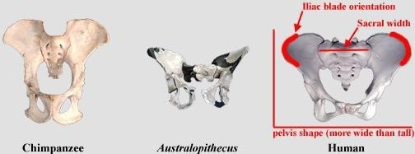

Species | Iliac blade orientation  (Curved forward or Flat) | Iliac blade width/height  (Broad/Short or Narrow/Tall) | Sacrum Width  (Broad or Narrow)
Humans | Curved forward | Broad/ Short | Broad
Chimpanzees | Flat | Narrow/ Tall | Narrow
Australopithecus | Curved forward | Broad/ Short | Broad

  - Does Australopithecus appear to have more chimpanzee-like or human-like pelvic morphology?

Australopithecus appear to have more human like pelvic morphology.

  - Based on your answer, what would you say about the locomotion of Lucy?

Lucy was clearly bipedal.

- Recall that humans have a valgus knee as a result of a bicondylar angle that tilts the shaft of the femur toward the body’s midline. We’ve drawn the human bicondylar angle on the image below to illustrate this point.
  - Why is a bicondylar angle important for a biped?
The foot is closer to the body’s center of gravity during single-foot support, relieving stress on the knee joints and ensuring balance during bipedal locomotion.

  - 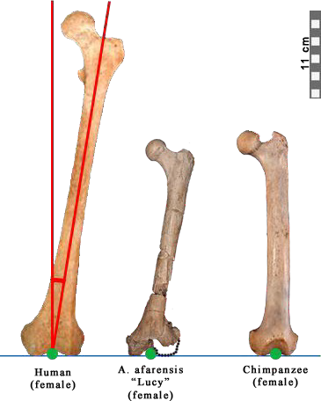Draw the bicondylar angles for A. afarensis and a chimpanzee. To draw the angle, first draw a line perpendicular to the blue line, starting at the green dot. Then, draw a line through the middle of the femur’s shaft.

Line perpendicular to blue line
(infracondylar plane)

Line through shaft of femur

  - Based on your drawing, does the Australopithecus femur exhibit a more human- like or more chimp-like bicondylar angle?
Human like.

  - What can you conclude about the locomotion of Lucy based on your answer?

She was most likely bipedal when on ground.

Based on your reading and the above exercise, answer the following questions:

- Why was the discovery of Lucy so important?

Lucy's completeness (40%) as a fossil skeleton is a rarity. Through analyzing the different bones from one skeleton we are able to better understand her locomotion, diet and relatedness to humans. (pg 2& pg 4)

- What is a good way to determine Lucy’s evolutionary relationship to humans and other living primates? Why? Hint: Think of a type of systematics discussed above using derived and primitive characters.

Cladistics helps us understand the evolutionary relationships among organisms by using primitive and derived characters to determine the most likely shared ancestry between groups. (pg 3)

- What happened to Lucy, after her death, that allows us to observer her as a fossil today? Describe the process(es)?

After Lucy died, her bones settled in sediments. As the sediments built up over time, part of her skeleton was crushed. The calcium in her bones was replaced by the minerals of the surrounding soils and eventually the bones become hard as rocks. Time and erosion eventually brought Lucy, now a fossil to the surface.

- What did Lucy look like?

Lucy was short in height (107 cm) and she weighed (27.3 kgs) .She was a female and probably had chimpanzee like face.

- Lucy had a unique way of moving around in her environment. List and then describe the features of her skeletal anatomy that were discussed in the reading, and determine if this was a primitive or derived character for hominins. Remember hominins include human and other primates that walked bipedally.

Limb proportions- Lucy has an intermediate intermembral index between chimpanzees and humans. This is derived character, since this is evidence that the skeletal morphology of hominins was evolving towards longer legs. (pg 7)

Scapula - The orientation of the globoid fossa indicates she was able to climb trees with ease. This is a primitive character since arboreal locomotion is present in many primates. (pg7)

Innominate - Lucy's innominate blades are short, broad and curved forward - traits that affects muscle attachment in the hips , aiding in bipedal locomotion. This is a derived character since Lucy's innominate was very similar to humans and different than the tail, narrow and flat innominate of chimpanzees. (pg 8)

Sacrum - Lucy's sacrum is wide at the top and short in length, similar to humans. Chimpanzee sacra are tall and narrow, so Lucy's sacrum is a derived character. (pg.8)

Femur - Lucy's femur exhibits a bicondylar angel, which also results in a valgus knee. These traits are hallmarks of bipedal locomotion. This is not present in quadrapedeal apes, and therefore is a derived character. (pg 9)

Foot - Lucy has long and curved toes which were advantageous for tree climbing. This is a primitive character.


G. References

- Johanson DC, Lovejoy CO, Kimbel WH, White TD, Ward SC, Bush ME, Latimer BM and Coppens Y. 1982. Morphology of the Pliocene partial hominid skeleton (A.L. 288-1) from the Hadar formation, Ethiopia. American Journal of Physical Anthropology 57(4):403-451.

- Kimbel, W H and Delezene LK. 2009. “Lucy” redux: A review of research on Australopithecus afarensis. Yearbook of Physical Anthropology 52:2–48.

- Walter RC. 1994. Age of Lucy and the first family: single-crystal 40Ar/39Ar dating of the Denen Dora and lower Kada Hadar members of the Hadar Formation, Ethiopia. Geology 22:6–10.

- Aronson JL and Taieb M. 1981. Geology and paleogeography of the Hadar hominid site, Ethiopia. In G Rapp and CF Vondra (eds.): Hominid Sites: Their Geologic Setting; A.A.A.S. Selected Symposium No. 63. Boulder: Westview, pp. 165-195.

- Reed KE. 2008. Paleoecological patterns at the Hadar hominin site, Afar Regional State, Ethiopia.
Journal of Human Evolution 54:743–768.

- Teaford, MF and Ungar PS. 2000. Diet and the evolution of the earliest human ancestors.
Proceedings of the National Academy of Sciences 97:13506–13511.

- Ryan AS, Johanson DC. 1989. Anterior dental microwear in Australopithecus afarensis: comparisons with human and nonhuman primates. Journal of Human Evolution 18:235–268.

- Jungers WL. 1988. Lucy’s length: stature reconstruction in Australopithecus afarensis (A.L. 288-1) with implications for other small bodied hominids. American Journal of Physical Anthropology 76:227-232.

- McHenry HM. 1992. Body size and proportions in early hominids. American Journal of Physical Anthropology 87:407–431.

- Klein RG. 2009. The Human Career: Human Biological and Cultural Origins, 3rd ed. Chicago: University of Chicago Press.

- Cartmill M and Smith FH. 2009. The Human Lineage. New York: John Wiley Sons.

- Morbeck ME and Zihlman AL. 1989. Body size and proportions in chimpanzees, with special reference to Pan troglodytes schweinfurthii from Gombe National Park, Tanzania. Primates 30, 369–382.

- Stern JT and Susman RL. 1983. The locomotor anatomy of Australopithecus afarensis. American Journal of Physical Anthropology 60:279–317.

